Creating a PowerSchool ID for Admins

In order to utilize Unified Classroom, you will need to create a PowerSchool ID. Creating your PowerSchool ID is a one-time process.

Getting Started
- Go to your district’s URL (https://ps.###.misd.net/admin).
- On the Staff tab, search for your user account.
- Once you are on the Staff screen, click Security Settings.
- Verify and/or create your Teacher Username and Teacher Password.
- Click Submit.

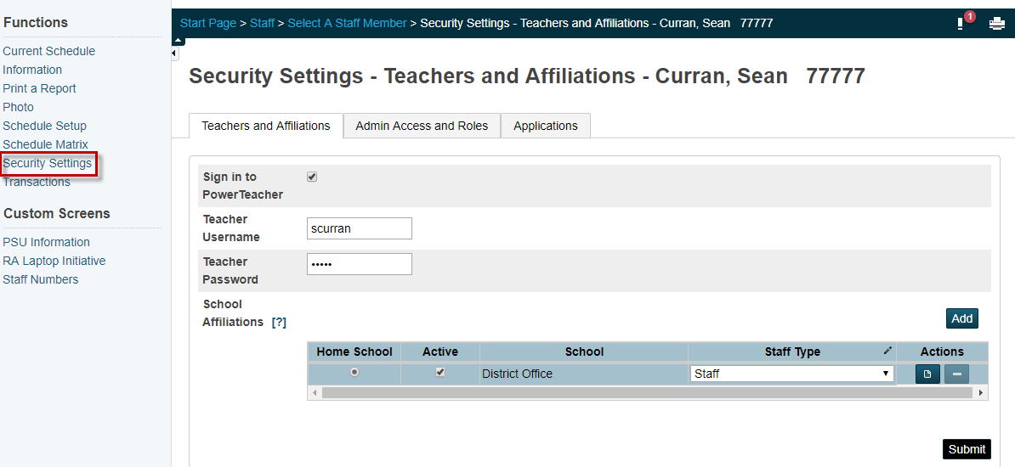

Create your PowerSchool ID
- Go to your district’s URL for teachers (https://ps.###.misd.net/teachers).
- On the Welcome to Unified Classroom screen, click on Create PowerSchool ID.

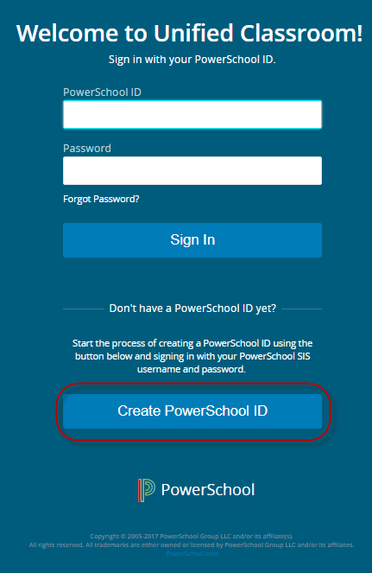

- Sign in with your existing PowerTeacher portal username and password.
- On the following screen, click Continue.
- Enter the email you want to use as your PowerSchool ID username. This should be your school or school district email address.
- Enter the password you want to use as your PowerSchool ID password. Passwords must be between 8 and 64 characters with no more than three repeating characters. Passwords do not expire.
- Click Create PowerSchool ID. You will need this information to sign in to Unified Classroom in the future. 8. Click Continue to Unified Classroom Sign In.

Unchecking the “Sign in to PowerTeacher” Checkbox

You will now have to navigate go back to your district’s admin URL (https://ps.###.misd.net/admin).
- On the Staff tab, search for your user account.
- Once you are on the Staff screen, click Security Settings.
- Uncheck Sign in to PowerTeacher.
- Click Submit.
